Scope of Work for Tax Map Key (TMK): (1) 2-9-075:042 Manoa
The table below contains the State’s current estimate of the schedule and significant dates. All times are Hawaii Standard Time (HST). If a component of this schedule, such as "Bid quotes Due Date and Time" is delayed, the rest of the schedule may likely be shifted by the same number of days. Any change to the IFB Schedule and Significant Dates prior to the bid quote due date shall be issued by addendum.
Event | Date
Solicitation Release: | 7/20/2026
Question Submittal Deadline: | 7/27/2026, 4:00 P.M.
Answers to Questions: | 7/28/2026, 4:00 P.M.
Bid quote Due Date and Time: | 7/30/2026, 2:00 P.M.
Evaluations | 7/30/2026 – 7/31/2026
Estimated Date for Discussions, if necessary | TBD
Estimated Due Date for BAFO, if necessary | TBD
Anticipated Award Date: | 7/31/2026 2:00 P.M.

*Supporting documentation must be either uploaded to HIePRO or submitted to darlene.bryant@hawaii.gov.
A. SCOPE OF WORK:
- Removal of ten (10) trees. Leaving stump no higher than four (2) feet. See photos C2 to C-12 for tree photos.
- Trim and remove vegetation with branches/trunk 3 inches in diameter or larger, growing along and above stream to 5 feet back from water’s edge of stream, and going upward to sky, including all hanging branches within that zone for 330 feet in length.
- No chemical growth inhibitors, herbicides, stump treatments, or similar products shall be applied to any stump.
- Cut trunks/vegetation must be disposed off-site and at an authorized facility. No chemical growth inhibitors, herbicides, stump treatments, or similar products shall be applied to any stump.
B. GENERAL NOTES
- All work shall be done between 8:00 a.m. to 4:30 p.m., Monday through Friday (excluding State holidays) except with the prior approval of ODLO.
- The Contractor shall be responsible for verifying the location of all utilities and structures. Any damage, injury, and/or loss to any property resulting from the performance of the work shall be the sole responsibility of the Contractor, and shall be remedied promptly by the Contractor at his own expense.
- The Contractor will be provided contact information for the sites to coordinate physical access to the site, if needed.
- The Contractor shall provide safety signs, barricade, and other devices necessary for the safety and convenience of the general public.
- The Contractor shall observe all applicable Federal, State, and Municipal acts, statutes, ordinance, and rules pertaining to the performance of this job.
- The bid award shall be based on the availability of funds.
- Submission of bid shall be the evidence that the Contractor understands the scope of the job described herein.
- If erosion and sediment control measures are needed, they will be in place before earth-moving and dredging activities begin. Functionality of erosion and sediment control devices will be maintained throughout the construction period.

C. MAP OF AREA:
See map on following page and trimming/removal of vegetation C1-C12.

TMK (1) 2-9-075:042 Manoa
Job area is highlighted red
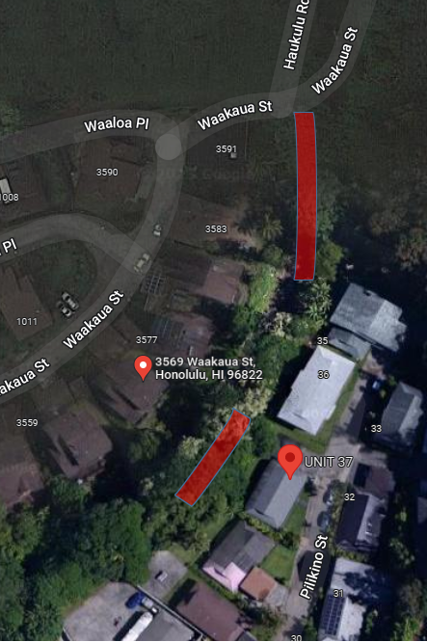

TMK (1) 2-9-075:042 Manoa
Exhibit C1
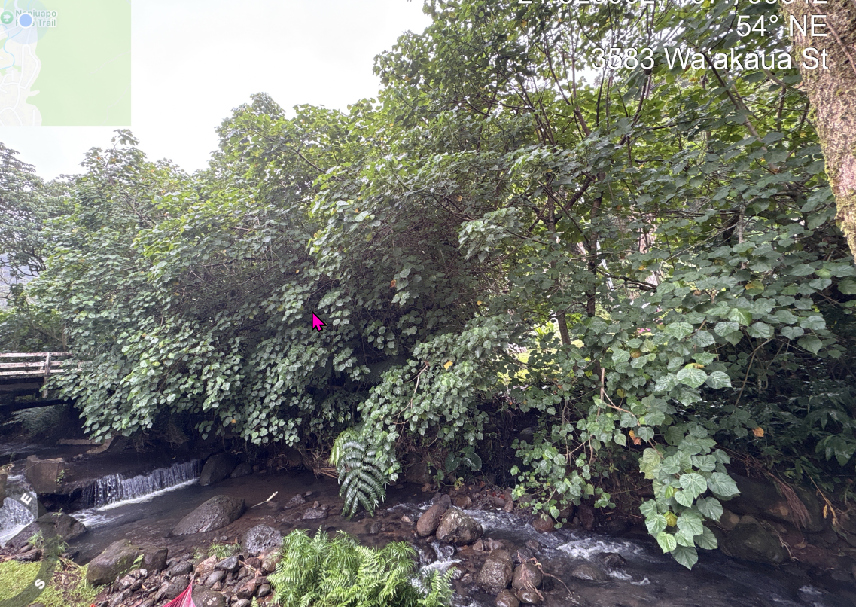
Remove vegetation Start from bridge 330 ft. downstream.

TMK (1) 2-9-075:042 Manoa
Exhibit C2
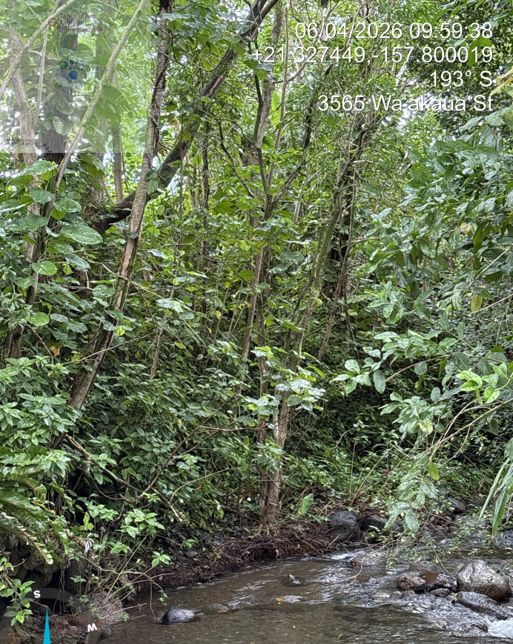
Remove vegetation Start from bridge 330 ft. downstream.

TMK (1) 2-9-075:042 Manoa
Exhibit C3 Tree 1

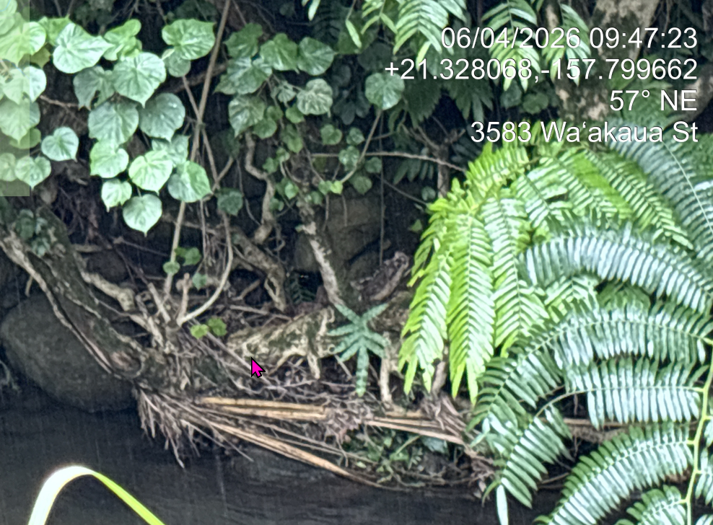
Remove tree #1
Tree #1: Cut any clonal cluster of sapling/trunks emerging from the root system.
Remove tree #1

TMK (1) 2-9-075:042 Manoa
Exhibit C4 Tree 2
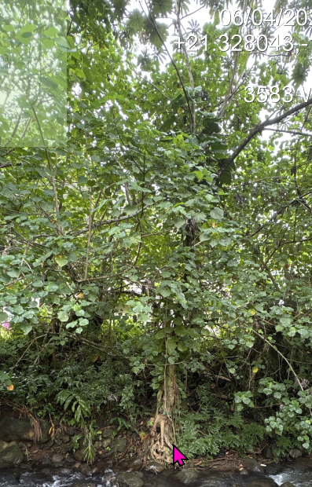
Remove tree#2
Tree #2: Remove tree – stump 2 feet.

TMK (1) 2-9-075:042 Manoa Estates
Exhibit C5 Tree# 3
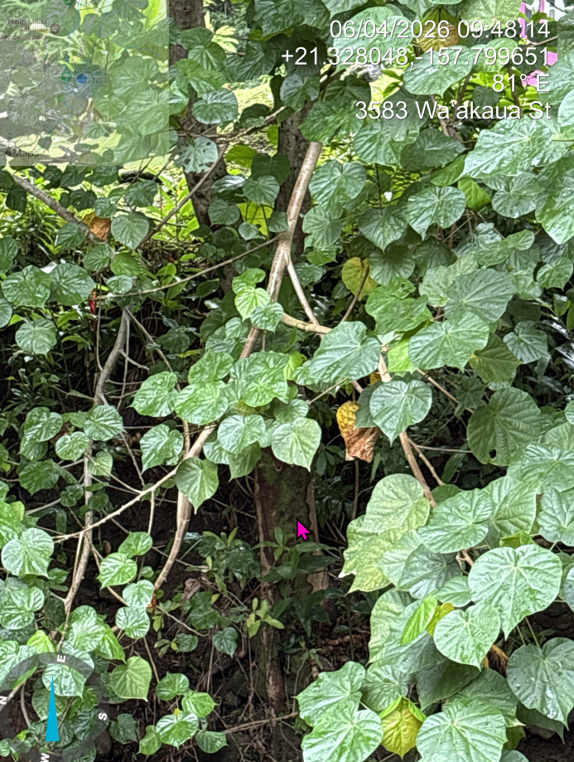
Remove tree #3
Tree# 3: Remove tree – stump 2 feet.

TMK (1) 2-9-075:042 Manoa Estates
Exhibit C6 Tree 4
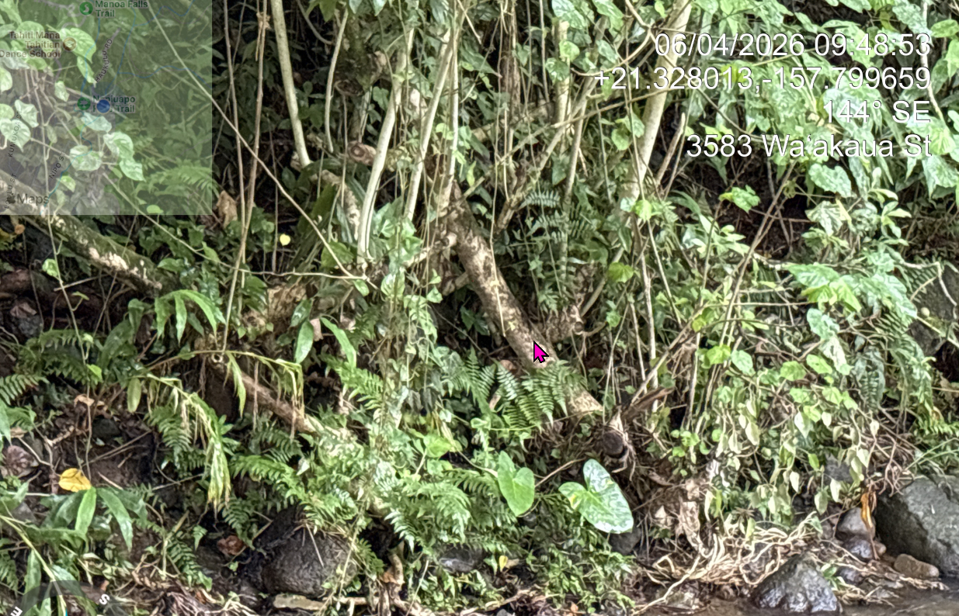
Tree #4 REMOVE all root-connected trees
Tree #4: Remove all root connected trees – stump 2 feet.

TMK (1) 2-9-075:042 Manoa
Exhibit C7 Tree 5
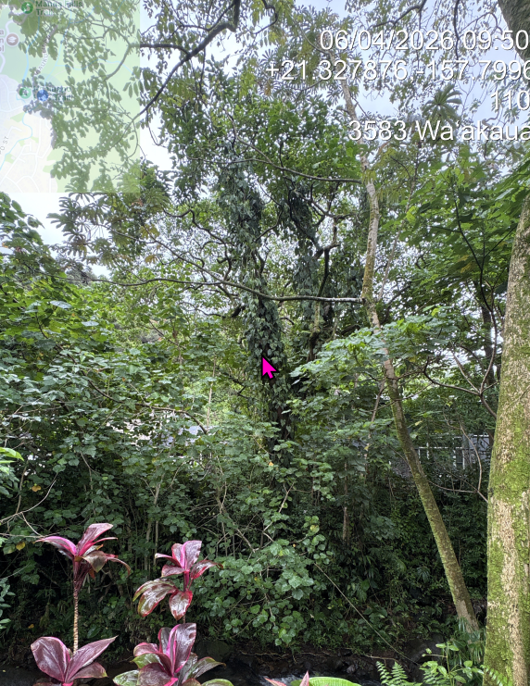
Tree #5 REMOVE
Tree #5: Remove tree – stump 2 ft.

TMK (1) 2-9-075:042 Manoa
Exhibit C8 Tree 6
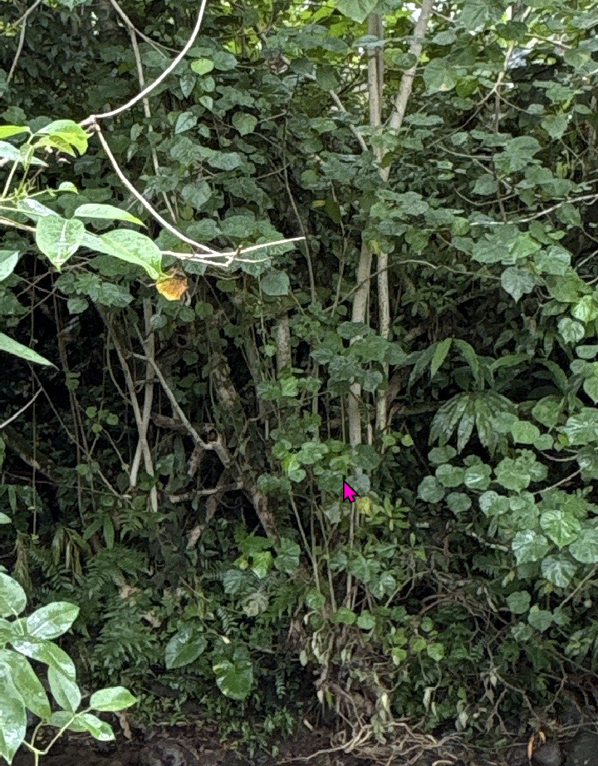
Trees #6 REMOVE all root connected trees
TMK (1) 2-9-075:042 Manoa
Exhibit C9 Tree 7

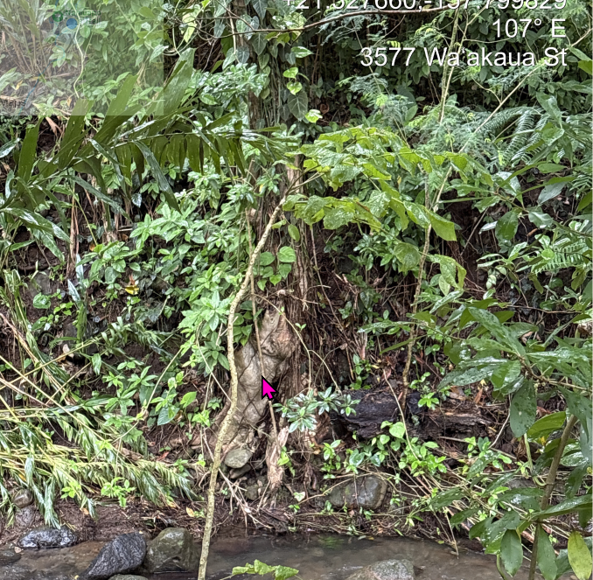
Tree #7 REMOVE all root connected trees

Tree #7 Remove all root connected trees- cut stump 2 ft.

TMK (1) 2-9-075:042 Manoa
Exhibit C10 Tree 8
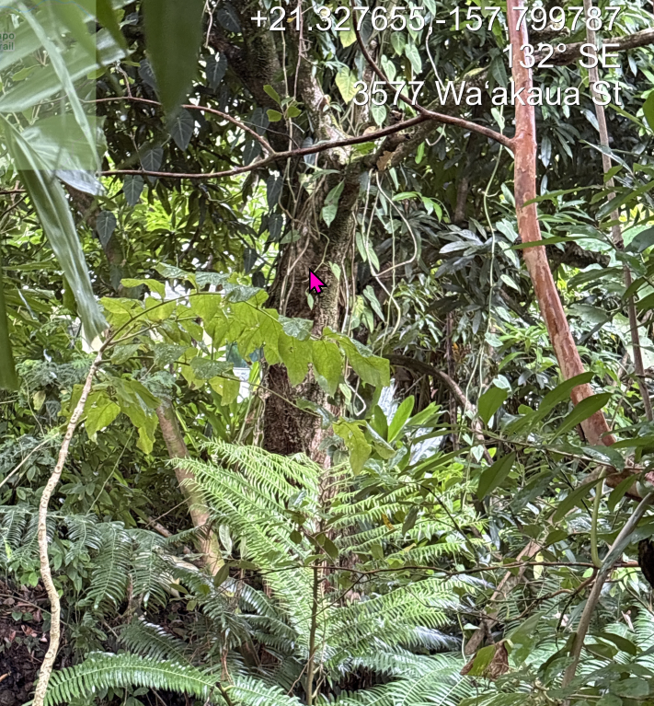
Tree #8 REMOVE

Tree #8: Remove tree- stump2 ft.

TMK (1) 2-9-075:042 Manoa
Exhibit C11 Tree 9
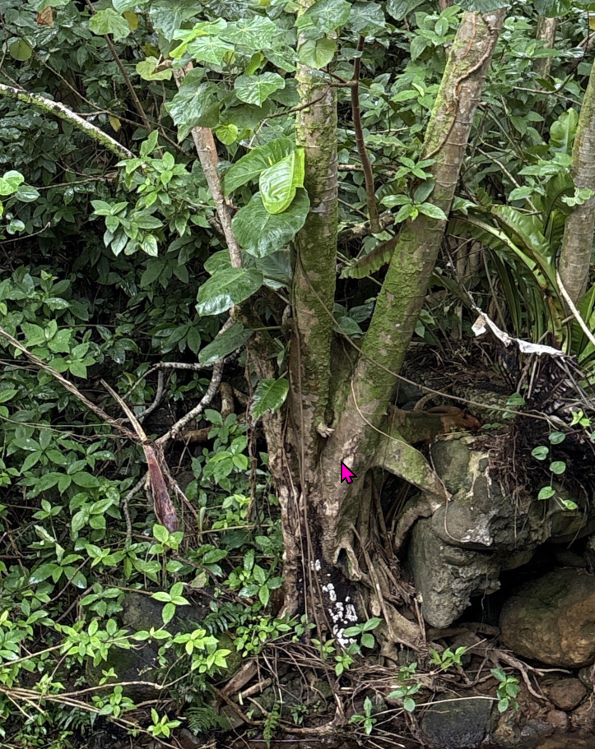
Tree #9 REMOVE

Tree #9: Remove tree- stump 2 ft.

TMK (1) 2-9-075:042 Manoa
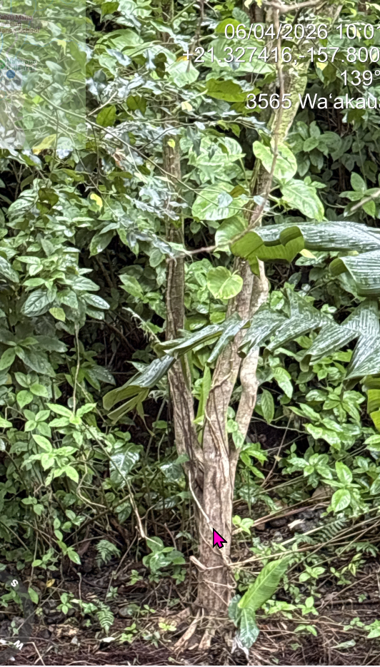
Exhibit C12 Tree 10
Tree #10 Remove

Tree #10- Remove tree- stump 2ft.

